Contour lines for Lot 61A
Lot 36 metre long and 15.44 metre wide
Here are two methods to calculate the distance of contour lines
- Proportional distance can be calculated using the following equation.
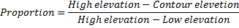
For the 9.5 m contour measured between M and D Lot 61 this would result in:
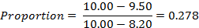
The 9.50 m contour line would be located 0.278 of the distance between the two stations.
The distance measured from M is therefore D₁.= 278 x 15.44 = 4.24 m (15.24-4.24 = 11.00)
The next proportion for contour line 9.0 m is:
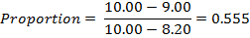
The distance measured from M is therefore D₂ = 0.555 x 15.24 = 8.458 m (15.24-8.458 = 6.78)
The next proportion for contour line 8.5 m is:
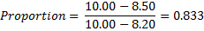
The distance measured from M is therefore D₃ = 0.833 x 15.24 = 12.695 m (15.24-12.695 = 2.545)
Whatever system you use the results are the same D₁ = d₃ D₂ = d₂ and D₃ = d₁
But be aware from which point (RL) you need to measure the distance
- Similar triangles can also be used to calculate the distance.

Example:
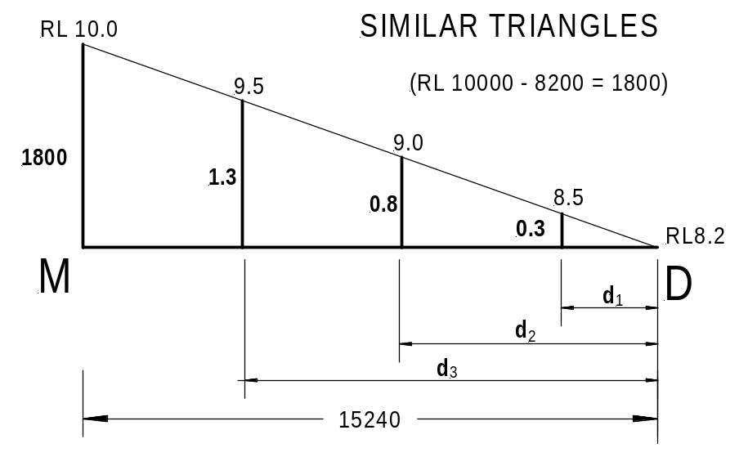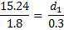
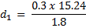
d₁ = 8.467 × 0.3 = 2.540
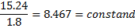
d₂ = 8.467 × 0.8 = 6.773
d₃ = 8.467 × 1.3 = 11.007

